EXPERIMENT-5

AIM:

To examine whether zener regulator is working in breakdown region and calculate load current, zener current, current through series resistor, load voltage and verify it with multisim software.

THEORY:

The primary objective of Zener diode as voltage regulator is to maintain constant voltage. We use Zener diode to maintain a constant potential difference across the load resistance when supply voltage is more than Zener voltage.

PROCEDURE:

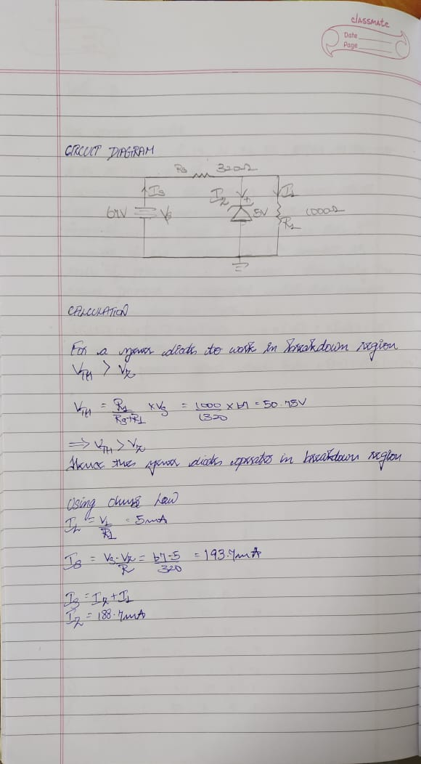

MULTISIM:

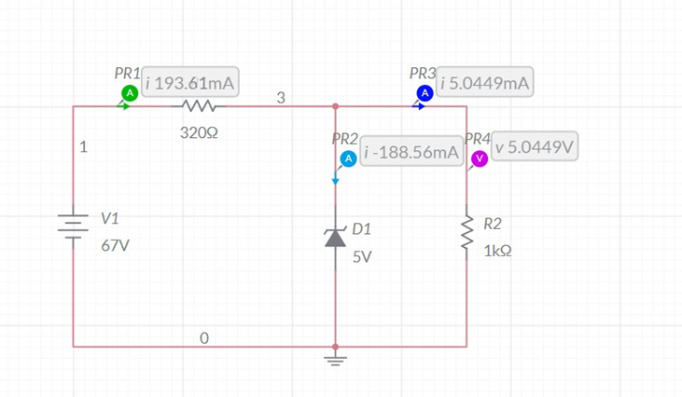

CONCLUSION:

The value of Zener voltage, Zener current, current through series resistor , load current using theoretical calculations and through MULTISIM are same.

NAME: G R NITIN

ROLL NO: CB.EN.U4CYS21017